Author: Jessica Stephenson

Kumalo, Sydney
Sydney Alex Kumalo (also documented as Khumalo) (b. 1935, Sophiatown,
Johannesburg, Gauteng (then Transvaal) South Africa - d. 1988,
Johannesburg, Gauteng (then Transvaal), South Africa).
Sydney Kumalo was an important early black modernist working primarily
in cast metal sculpture and drawing. As artist and educator, Kumalo's
contribution was twofold: an embrace of sculpture at a time when most
urban South African modernists worked exclusively in 2D media, and a sophisticated
rethinking of African sculptural forms through the language of
international modernism in counterpoint to the naïve social realism of
"township" art of the day. Kumalo initiated his art career at the
Polly Street Art Center in Johannesburg. Here he trained from 1952 to
1957 under Cecil Skotnes; subsequently he apprenticed to the sculptor
Eduardo Villa until 1959. Early on Kumalo developed an interest in
traditional West and Central African sculpture, as well as Cubism and
mid-century European modernism and its related primitivism, most
notably the work of Marino Marini, Henry Moore and Lynn Chadwick.
Kumalo collaborated on a number of public art projects with Cecil
Skotnes, and together with other South African artists including
Villa, Skotnes, Cecily Sash, Guiseppe Cattaneo and Ezrom Legae, he
exhibited locally and internationally as part of the multi-racial
modernist Amadlozi Group. These collaborations speak to Kumalo's
refusal to accept the dictates of apartheid ideology.
From 1960 to 1964 Kumalo served as the first black art instructor at
the Polly Street Art Center and the Jubilee Social Centre, where he
shaped the sensibilities and styles of a generation of modern black
South African artists including Ezrom Legae, Leonard Matsoso and Louis
Maqhubela. He advocated for drawing artistic inspiration from African
heritage as well as universal themes, and for the development of a
contemporary African idiom through the language of international
modernism. He also encouraged his students to pursue art as a
full-time professional career which, after 1965 he achieved. This was
an exceptional accomplishment for a black South African artist of the
time. Until his death in 1988, Kumalo remained active in international
and regional exhibition arenas. He traveled widely and achieved
notable recognition for his work through awards and participation in
such prestigious events as the Venice and Sao Paulo Biennales. In 1967
Kumalo was a guest of USSALEP (the United States South Africa
Leadership Exchange Program) during a visit to the USA. He also
visited Germany in 1979, with a return to the USA in 1985. His work
is featured in the collections of the Durban Art Museum; Johannesburg
Art Gallery; Rembrandt van Rijn Art Foundation; Sandton Town Council;
Iziko South African National Gallery; Sanlam Art Collection,
Bellville; De Beers Centenary Art Gallery, University of Fort Hare;
University of South Africa, Pretoria; and University of the
Witwatersrand, Johannesburg.
References and Further Reading:
Peffer, J. (2009) Art and the End of Apartheid. Minneapolis:
University if Minnesota Press, 129 - 170.
Sack, S. (1988). The Neglected Tradition: Towards a New History of
South African Art (1930-1988), Johannesburg: Johannesburg Art Gallery,
107.

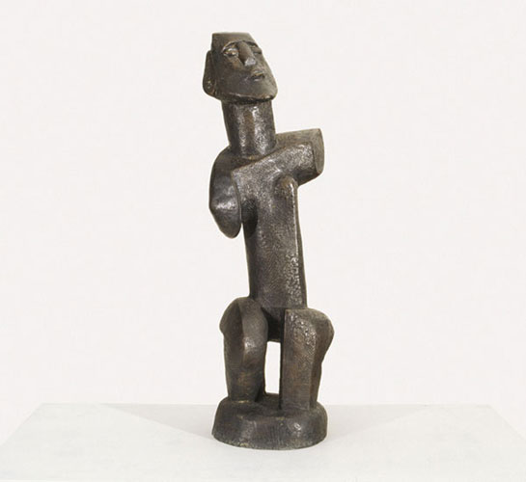

Image Caption:

Dancing Woman, bronze.

Image source: http://www.stevenson.info/exhibitions/season2005/images/item24.jpg

